**Module 2: Java Script and SQL**

1. Write a query to display customer number, customer’s firstname , account number where the account status is terminated. Display the records sorted in ascending order based on customer number and then by account number.

Query:-

SELECT c.customer_number,c.firstname,a.account_number

FROM account_master a JOIN customer_master c

ON c.customer_number=a.customer_number

WHERE a.account_status='Terminated'

ORDER BY c.customer_number,a.account_number;

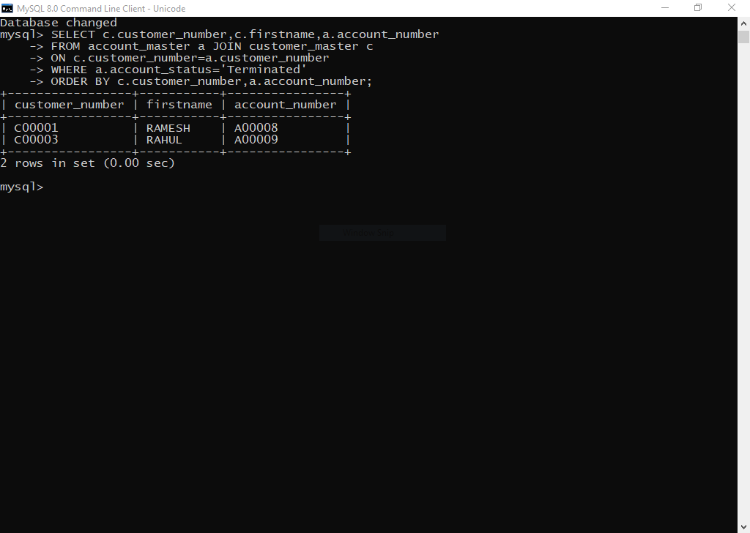

1. Write a query to display the number of accounts opened in each city. The query should display the Branch city and the number of No_of_Accounts for the branch city where we don’t have any accounts opened display 0. Display the records in the sorted order based on branch city.

Query:-

SELECT branch.branch_city, count(account.account_number) No_of_Accounts

FROM branch_master branch LEFT JOIN account_master account

ON account.branch_id=branch.branch_id

GROUP BY branch.branch_city ORDER BY branch_city;

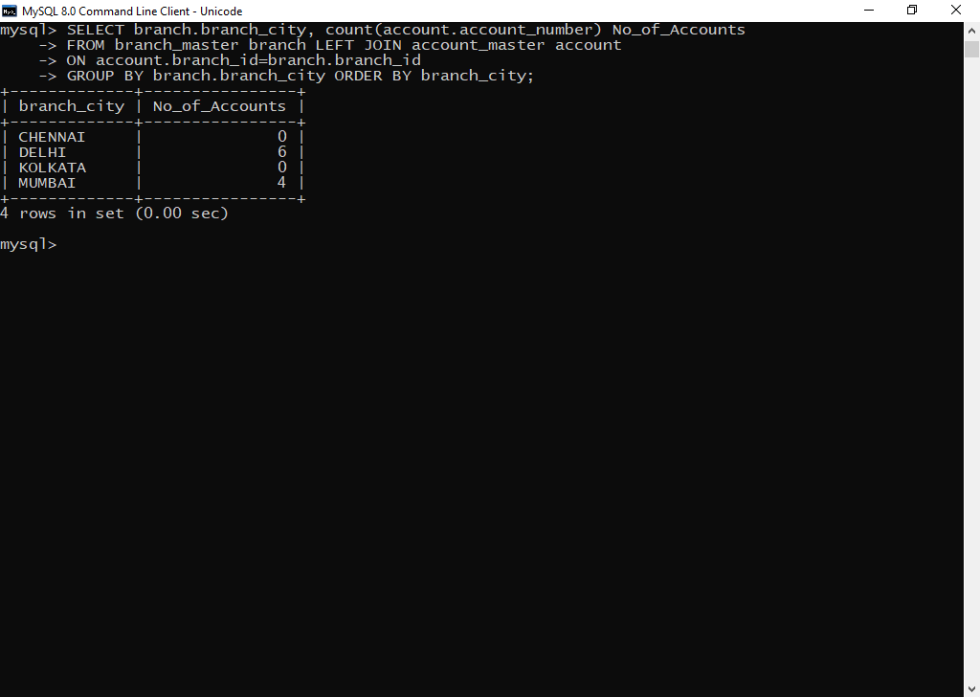

1. Write a query to display the customer number, customer firstname, customer lastname who has taken loan from more than 1 branch. Display the records sorted in order based on customer number.

Query:-

SELECT c.customer_number,c.firstname,c.lastname FROM

customer_master c JOIN loan_details l ON

c.customer_number=l.customer_number

GROUP BY l.customer_number HAVING count(l.branch_id)>1

ORDER BY c.customer_number;

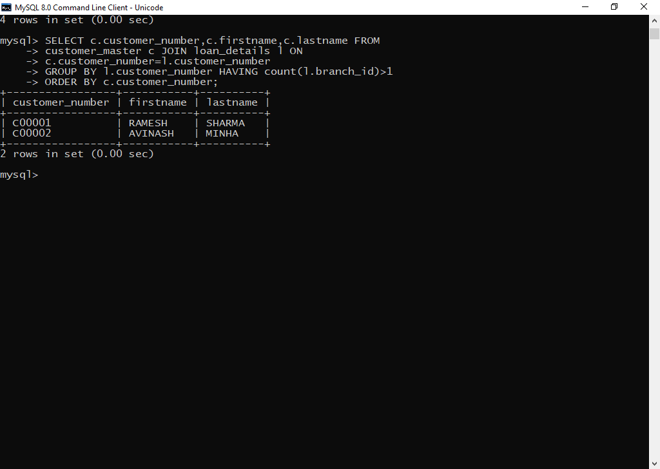

1. Write a query to display the number of clients who have asked for loan but they don’t have any account in the bank though they are registered customers. Give the count an alias name of Count.

Query:-

SELECT count(c.customer_number)Count FROM customer_master c JOIN loan_details l

ON c.customer_number=l.customer_number

WHERE c.customer_number NOT IN

(SELECT customer_number FROM account_master);

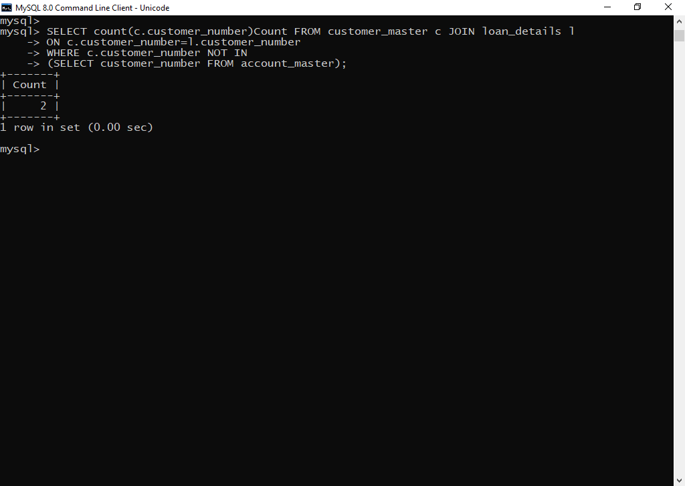

1. Write a equerry to display customers firstname, city and account number whose occupation are not business , Services or Student. Display the records sorted in ascending order based on customer firstname and by account number.

Query:-

SELECT c.firstname,c.customer_city,a.account_number FROM

Customer_master c JOIN account_master a ON a.customer_number=c.customer_number

WHERE c.occupation NOT IN ('Service','Student','Business')

ORDER BY c.firstname,a.account_number;

